**Food Chains and Food Webs**

Multiple Choice

1. State what is shown on a food chain.
2. How closely related organisms are.
3. Where organisms live on Earth.
4. Who eats whom in an ecosystem.
5. The adaptations organisms have.
6. Recall what a food chain shows the flow of.
7. Animals
8. Water
9. Oxygen
10. Energy
11. State what type of organism is always found at the bottom of a food chain.
12. Producer
13. Predator
14. Decomposer
15. Consumer
16. State what we call the organism at the very top of a food chain.
17. Ceiling species
18. Herbivore
19. Primary producer
20. Apex predator
21. State what is shown on a food web.
22. The overall flow of energy through an ecosystem.
23. Places inhabited by venomous spider species.
24. The flow of energy between organisms in an ecosystem.
25. The geographic area covered by an ecosystem.

The following 3 questions use the following picture.

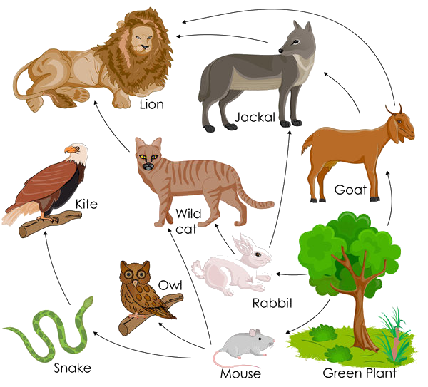

1. In this food web, identify what the wild cat eats.

(Select all that apply)

Select ALL correct options

1. Snake
2. Goat
3. Owl
4. Mouse
5. Rabbit
6. Green plant
7. In this food web, identify what the jackal eats.

(Select all that apply)

Select ALL correct options

1. Snake
2. Goat
3. Owl
4. Mouse
5. Rabbit
6. Green plant
7. In this food web, identify what the rabbit eats.

(Select all that apply)

Select ALL correct options

1. Snake
2. Goat
3. Owl
4. Mouse
5. Rabbit
6. Green plant

The following 3 questions use the following picture.

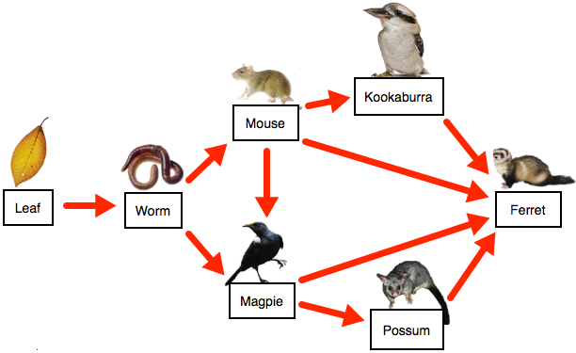

1. In the food web below, identify what is eaten by the magpie.

(There may be more than one correct answer!)

Select ALL correct options

1. Ferret
2. Kookaburra
3. Mouse
4. Worm
5. Leaf
6. Possum
7. In the food web below, identify what is eaten by the ferret.

(There may be more than one correct answer!)

Select ALL correct options

1. Possum
2. Leaf
3. Magpie
4. Mouse
5. Worm
6. Kookaburra
7. In the food web below, identify what is eaten by the worm.
8. Possum
9. Leaf
10. Magpie
11. Mouse
12. Worm
13. Kookaburra

Fill in the blanks

1. Use the following words to fill in the gaps.

**Rabbit, Fox, Grass**

**_______________ 🡪 __________________ 🡪 ___________________**

1. Use the following words to fill in the gaps.

**Shark, Seaweed, Fish**

**_______________ 🡪 __________________ 🡪 ___________________**

1. Use the following words to fill in the gaps.

**Deer, Grass, Wolf**

**_______________ 🡪 __________________ 🡪 ___________________**

1. Use the following words to fill in the gaps.

**Hawks, Grass, Mouse**

**_______________ 🡪 __________________ 🡪 ___________________**

1. Use the following words to fill in the gaps.

**Frog, Caterpillar, Flower**

**_______________ 🡪 __________________ 🡪 ___________________**

Short Answer

1. Distinguish between a food chain and a food web.
2. 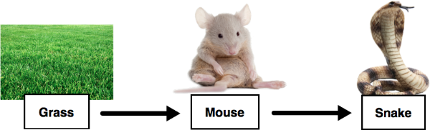

Discuss what is represented by the order of a food chain. Use the food chain above as an example and consider:

1. The types of organisms;
2. Their interactions with each other;
3. What the arrows mean.